**Introduction**

Team “Jaguar” has developed an application that simplifies the search experience for users who are looking to buy resale flats in Singapore. The app utilizes up-to-date data from the government to provide a seamless search experience and detailed information for users. It also allows users to filter HDBs by their preferences. Users are also able to view nearby facilities via the Google Map API implementation our application provides.

**Functional requirements**

System functionality to be performed

1.1. The system must allow users to search for HDB flats based on the following criteria.

1.1.1 Price range (SGD per square meter)

1.1.2 Housing type

1.1.3 Region of Singapore

1.1.4 Specific area

1.2. If the user searches for a specific price range, the system must show all HDB flats within that given range.

1.3 If the user searches for a specific area/region, the system must show all HDB flats within that area/region.

1.4 The system must allow the user to view detailed information about an HDB flat.

1.4.1 The detailed information must include:

1.4.1.1 Block No.

1.4.1.2 Type of flat

1.4.1.3 Address

1.4.1.4 MRT station of closest proximity and distance from it

1.4.1.5 Nearby entertainment hubs

1.4.1.6 Nearby government facilities

1.4.2 The flat must be highlighted if it is under BTO.

1.5 The user must be able to view the resale value history of HDB flats in a specified area.

1.6 The user must be able to search for nearby clinics and hospitals.

1.6.1 The system must show clinics and hospitals within 2km of a particular HDB flat.

1.7 The user must be able to search for schools.

1.7.1 The system must show schools within 2km of a particular HDB flat.

1.7.2 The user must be able to filter different types of schools including the following:

1.7.2.1 Kindergarten/Pre-school

1.7.2.2 Primary School

1.7.2.3 Secondary School

1.7.2.4 ITE

1.7.2.5 Polytechnic

1.7.2.6 Junior College

1.7.2.7 University

Information to be processed

2.1 The address of HDB flats must be displayed in the following format.

2.1.1 Street, Unit Number, Postal Code

2.2 Resale value must be displayed with a “$” sign, with a comma separating every 3 digits and 0 decimal places.

2.3 Distance must be displayed in “km” with 2 decimal places.

Interface with other systems

3.1 The system must retrieve the information of HDB flats from data.gov.sg

3.2 The system must retrieve the location of nearby clinics, hospitals, and schools from the Google Maps API.

**Use Case Diagram**

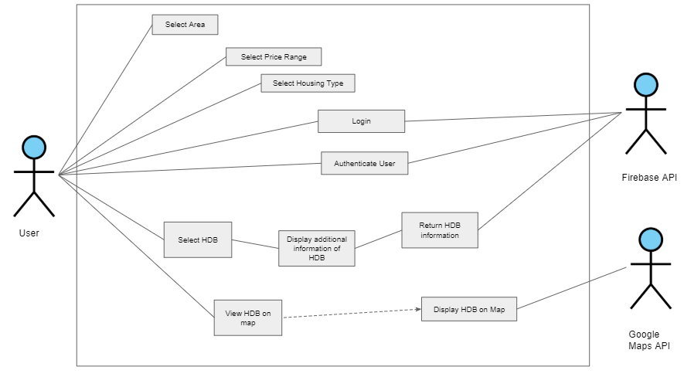

**Use Case Descriptions**

|  |  |  |  |
| --- | --- | --- | --- |
| **Use Case ID:** | **1** | | |
| **Use Case Name:** | **Logging in** | | |
| **Created By:** | **Tan Yi Cheng** | **Last Updated By:** | **Keerthan Arularasan** |
| **Date Created:** | **20/3/2020** | **Date Last Updated:** | **20/3/2020** |

|  |  |
| --- | --- |
| **Actor:** | System |
| **Description:** | Logging into account by authentication of username and password |
| **Preconditions:** | 1. User account must exist in firebase DB  2. Device must be connected to internet via Wifi or mobile data |
| **Postconditions:** | 1.User is able to access his account |
| **Priority:** | Medium |
| **Frequency of Use:** | 1-3 times per month |
| **Flow of Events:** | 1. Users enter their credentials in the login interface.  2. User selects the login button.  3. System validates the account by checking the user’s credentials with the database.  4. System authenticates the user to login successfully. |
| **Alternative Flows:** | AF-S1: User selects Register for account  1. User inputs desired credentials  2. System saves account credentials in database  3. Return to step 5  AF-S3: System detects empty username or password fields.  1. System displays error message “Username or password fields cannot be empty.”  2. User fills up the required field(s) for username and password.  3. User selects the login button to re-attempt login again.  4. Return to Step 2.  AF-S4: User enters the wrong credentials  1. System displays error message “Invalid username or password. Please re-enter.”  2. Return to Step 2. |
| **Exceptions:** | EX-AF-S1: User not logged in to their Facebook account.  1. System will prompt the user to enter their credentials to login to their Facebook account. |
| **Includes:** | 1.Validate the account availability |
| **Special Requirements:** | **-** |
| **Assumptions:** | Database refers to firebase DB. |
| **Notes and Issues:** | **-** |

|  |  |  |  |
| --- | --- | --- | --- |
| **Use Case ID**: | 2 | | |
| **Use Case Name**: | Searching for HDBs | | |
| **Created By**: | Kunyoung | **Last Updated By**: | Sherwinna |
| **Date Created**: | 20/3/2020 | **Date Last Updated**: | 20/3/2020 |

|  |  |
| --- | --- |
| **Actor**: | System |
| **Description**: | Search for HDBs based on the filtered criteria and display |
| **Preconditions**: | 1. User must be connected to the internet |
| **Postconditions**: | 1. The details of the selected HDB must be displayed |
| **Priority**: | High |
| **Frequency of Use**: | 1 - 10 times a day |
| **Flow of Events**: | 1. User starts the application and views the main menu. 2. User types in the desired area or region of HDB in the search bar 3. System provides autocomplete suggestions based on what the user has typed. 4. User accepts the suggestion and initiates the search 5. System lists out all relevant HDBs based on the user’s given criteria. 6. System lists the respective HDBs depending on user choice 7. User selects one of the HDBs to view its detailed information. 8. System will fetch the relevant data pertaining to the selected HDB and display it. |
| **Alternative Flows**: | AF-S3:   1. User rejects autocomplete suggestions and types his own input 2. System returns to Step 5   AF-S4:   1. User filters search based on price range and housing type. 2. System returns to Step 3. |
| **Exceptions**: | EX5:   1. System is unable to find any HDBs with the user’s criteria. 2. System will display an error message. 3. System will return back to Step 2. |
| **Includes**: |  |
| **Special Requirements**: |  |
| **Assumptions**: |  |
| **Notes and Issues**: |  |

**Class Diagram**

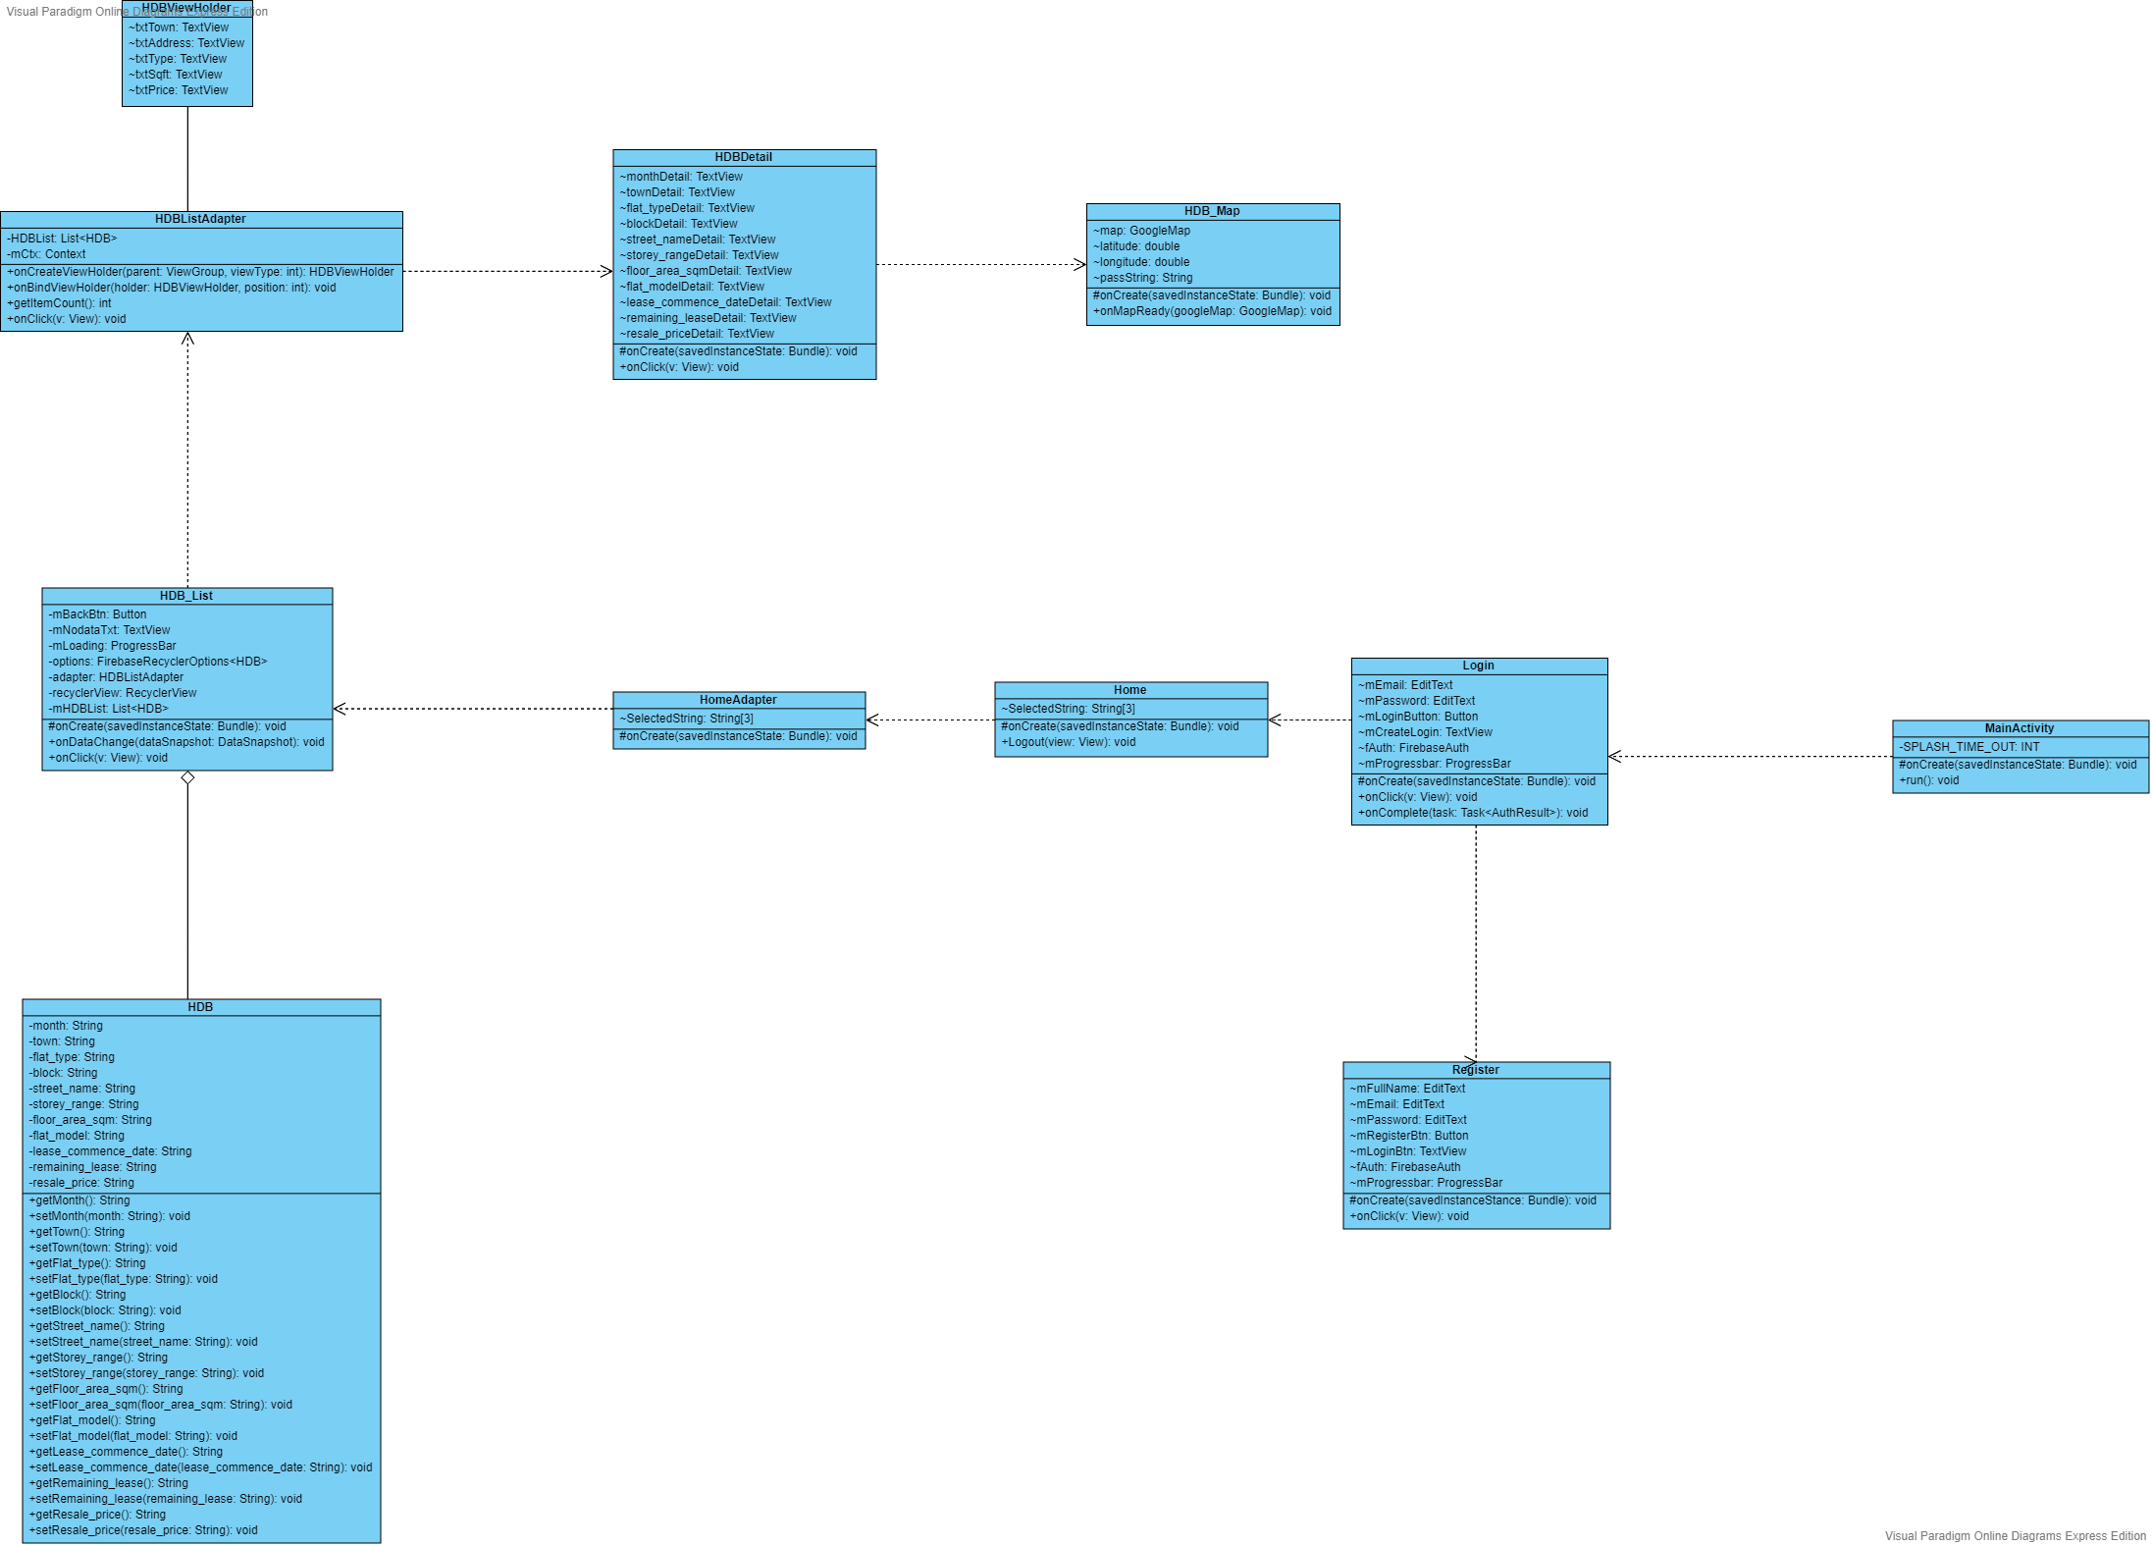

**Sequence Diagrams**

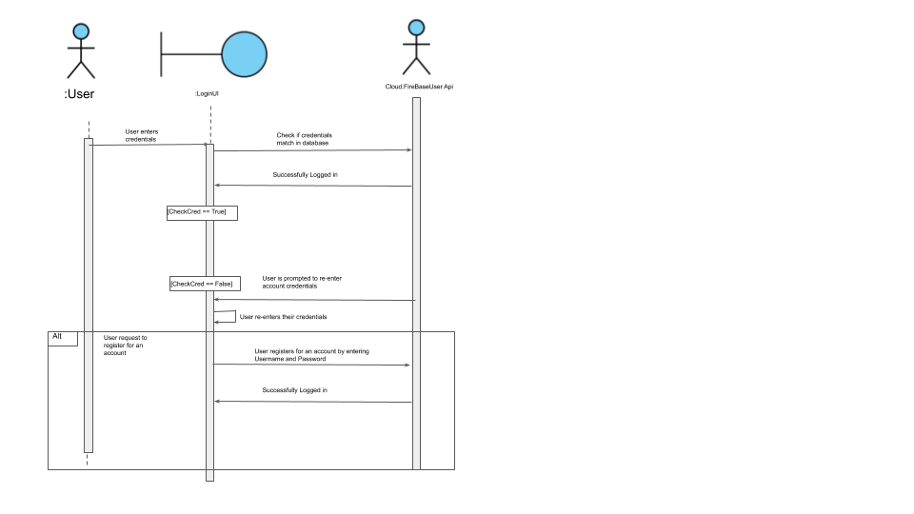

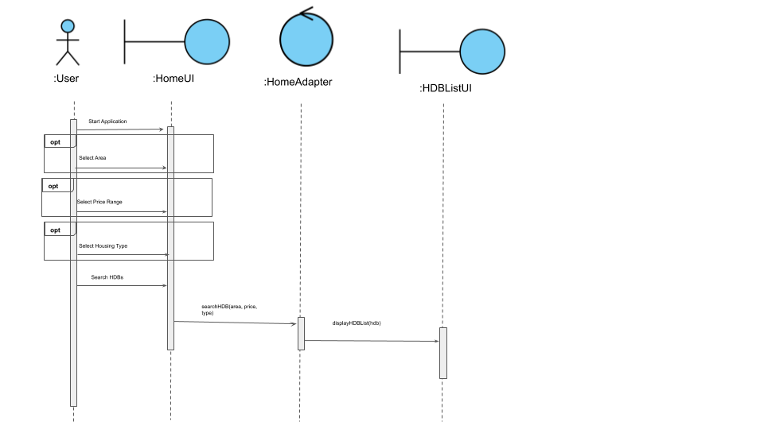

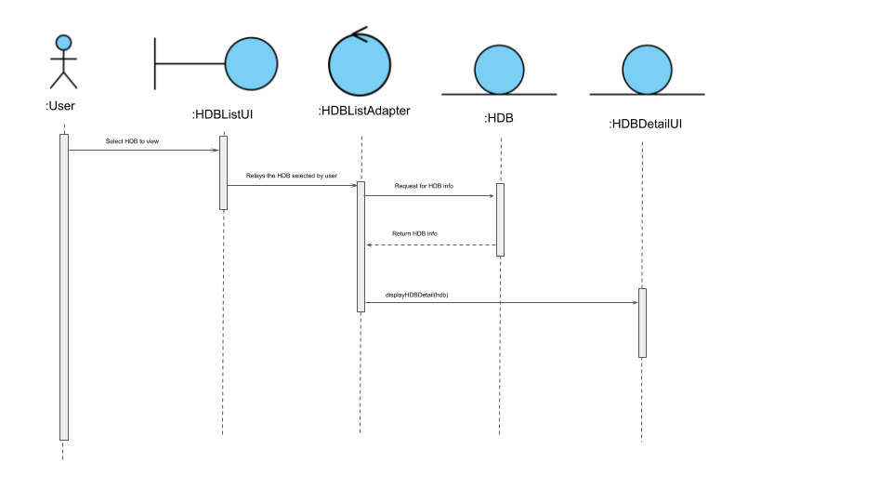

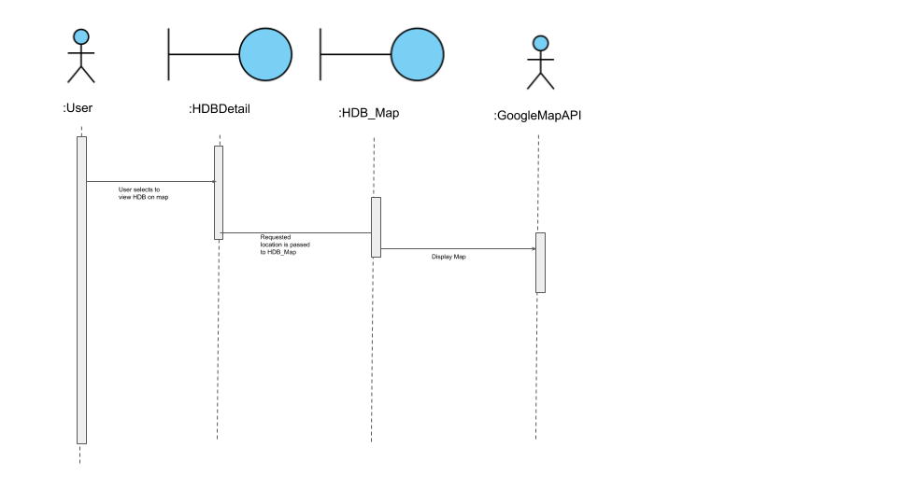

**Dialog Map**

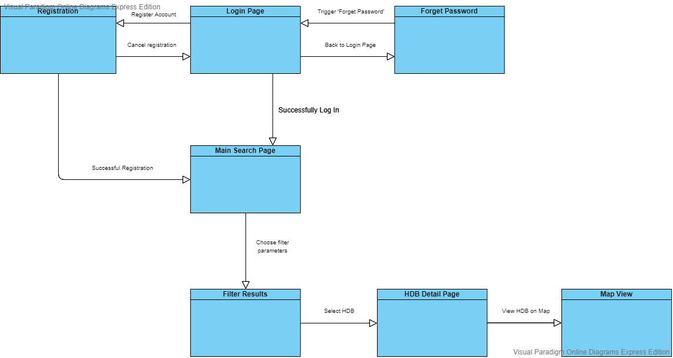

**Interface Requirements**

**User**

The application will be useful to all types of users who would like to buy or research on HDB prices and/or locations.

**Hardware**

The app requires hardware devices with internet connection to access the database.

**Software**

Designed to work primarily on Android devices

**Communication**

All features of the application will be available through the app itself

**Non-functional requirements**

Usability

1.1 The application must display help messages in English to aid users.

1.2 The application must display relevant error messages when errors occur.

1.3 The application must display suggestions when the user is typing in the search bar.

Reliability

2.1 The system must display up to date(within 6 months) information about HDB flats.

2.2 The system must not crash upon opening the application.

Performance

3.1 The system must be able to retrieve the information of HDB flats that are searched for within 5 seconds.

3.2 The system must be able to retrieve the information of nearby clinics and hospitals within 3 seconds.

3.3 The system must be able to retrieve the information of nearby schools within 3 seconds.

3.4 The application must display the main menu within 5 seconds after launch.

Supportability

4.1 Data of the HDB flats will be stored in XML format for ease of access and update.

**Data dictionary**

|  |  |
| --- | --- |
| HDB Flats | A unit of housing owned by the Housing and Development Board (HDB) that is available for purchase. |
| User | A human that interacts with the application to find out information about HDB flats. |
| System | The application itself, able to retrieve data of HDB flats. |
| Entertainment Hubs | Places of entertainment such as sports hubs and malls. |
| Government Facilities | Facilities provided by the government such as Postal Office, Community Centres, and CPF building. |